
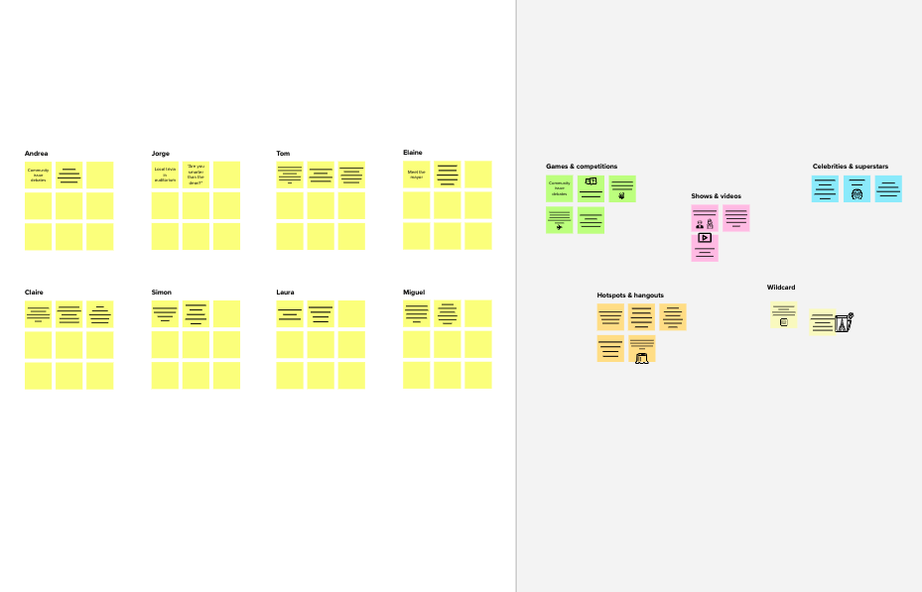


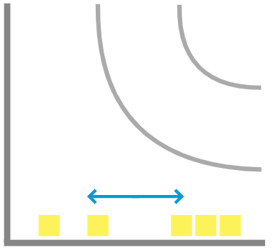
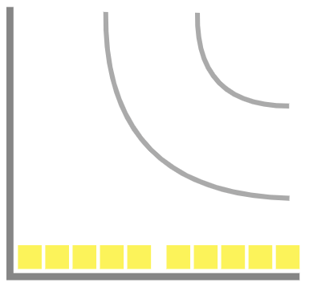
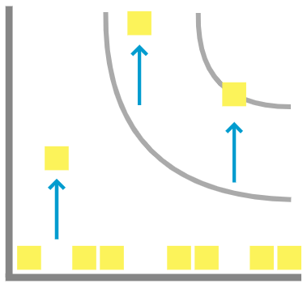
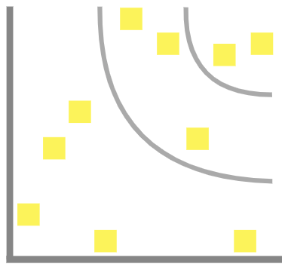






5 minutes
2

Brainstorm
Write down any ideas that come to mind that address your problem statement.

10 minutes
Person 1
Person 2
Stay in topic.
Encourage wild ideas.
Defer judgment.
Listen to others.
Go for volume.
Person 3
Person 4

Need some inspiration?
See a finished version of this template to kickstart your work.

Open example

1

Define your problem statement
What problem are you trying to solve? Frame your problem as a How Might We statement. This will be the focus of your brainstorm.
C Learn how to use the facilitation tools
Use the Facilitation Superpowers to run a happy and productive session.

Open article
B Set the goal
Think about the problem you'll be focusing on solving in the brainstorming session.
A Team gathering
Define who should participate in the session and send an invite. Share relevant information or pre-work ahead.
Before you collaborate
A little bit of preparation goes a long way with this session. Here’s what you need to do to get going.
10 minutes
10 minutes to prepare 1 hour to collaborate
2-8 people recommended
Brainstorm
& idea prioritization
Use this template in your own brainstorming sessions so your team can unleash their imagination and start shaping concepts even if you're not sitting in the same room.
Improve farmer income by understanding crop productivity and regional performance.
. Improve agricultural productivity by identifying crop cultivation and production patterns across states and seasons.

Develop an interactive dashboard to simplify complex agricultural data for farmers, researchers, and policymakers.

Reduce regional disparities in agricultural production by understanding cultivation and yield patterns across India.
Promote sustainable agriculture by identifying efficient crop cultivation practices and yield trends.

Strengthen food security by analyzing crop production trends and identifying high-producing regions.
Promote sustainable agriculture by identifying efficient crop cultivation practices and yield trends.

Help farmers choose suitable crops for different seasons and regions using historical agricultural data.

PROBLEM
How might we improve agricultural data to improve agricultural productivity and profitability?

TIP
You can select a sticky note and hit the pencil [switch to sketch] icon to start drawing!
3
4
Group ideas
Take turns sharing your ideas while clustering similar or related notes as you go. Once all sticky notes have been grouped, give each cluster a sentence-like label. If a cluster is bigger than six sticky notes, try and see if you and break it up into smaller sub-groups.
Prioritize
Your team should all be on the same page about what's important moving forward. Place your ideas on this grid to determine which ideas are important and which are feasible.
After you collaborate
You can export the mural as an image or pdf to share with members of your company who might find it helpful.
20 minutes
20 minutes
Quick add-ons
+
A Share the mural
Share a view link to the mural with stakeholders to keep them in the loop about the outcomes of the session.
Increase Agricultural Production
. Improve agricultural productivity by identifying crop cultivation and production patterns across states and seasons.
Improve farmer income by understanding crop productivity and regional performance.
. Support policymakers in efficient resource allocation and agricultural planning.
Help farmers choose suitable crops for different seasons and regions using historical agricultural data.
Strengthen food security by analyzing crop production trends and identifying high-producing regions.
B Export the mural
Export a copy of the mural as a PNG or PDF to attach to emails, include in slides, or save in your drive.
Keep moving forward
Strategy blueprint
Define the components of a new idea or strategy.

Open the template
Customer experience journey map
Understand customer needs, motivations, and obstacles for an experience.
Open the template
Suitable Crop Selection
Importance
If each of these tasks could get done without any difficulty or cost, which would have the most positive impact?
Strengths, weaknesses, opportunities & threats
Identify strengths, weaknesses, opportunities, and threats (SWOT) to develop a plan.
Open the template
-
-
Feasibility
Regardless of their importance, which tasks are more feasible than others? (Cost, time, effort, complexity, etc.)
+

Reduce regional disparities in agricultural production by understanding cultivation and yield patterns across India.
Promote sustainable agriculture by identifying efficient crop cultivation practices and yield trends.
Promote sustainable agriculture by identifying efficient crop cultivation practices and yield trends.
Promote sustainable agriculture by identifying efficient crop cultivation practices and yield trends.

Help farmers choose suitable crops for different seasons and regions using historical agricultural data.
. Improve agricultural productivity by identifying crop cultivation and production patterns across states and seasons.
Improve farmer income by understanding crop productivity and regional performance.

Develop an interactive dashboard to simplify complex agricultural data for farmers, researchers, and policymakers.

TIP
Add customizable tags to sticky notes to make it easier to find, browse, organize, and categorize important ideas as themes within your mural.

TIP
Participants can use their cursors to point at where sticky notes should go on the grid. The facilitator can confirm the spot by using the laser pointer holding the H key on the keyboard.
Template

